**RICE CROP DISEASE PREDICTION**

**ABSTRACT**

Identifying disease from the images of the plant is one of the interesting research areas in computer and agriculture field. This paper presents a survey of different image processing and machine-learning techniques used in the identification of rice plant diseases based on images of disease infected rice plants. This paper presents not only survey of various techniques but also concisely discusses important concepts of image processing and machine learning applied to plant disease detection and classification. We carry out detailed study of 19 papers, covering the work on rice plant diseases and other different plants and fruits, and present a survey of these papers based on important criteria. These criteria include size of image dataset, no. of classes(diseases), preprocessing, segmentation techniques, types of classifiers, accuracy of classifiers etc. We utilize our survey and study to propose and design our work on detection and classification of rice plant diseases.

**1.1 INTRODUCTION**

Applying wireless sensor network for monitoring paddy crop and pest identification is needed nowadays. Joining the sensor data alongside with Mobile application, benefit farmers to abuse their insight in a proficient path with a specific end goal to extricate the best outcomes from their paddy crop development. Our System provides a Mobile App which aggregates the ML algorithms for disease identification in the paddy crops. Rice is one of the important foods in India. Rice disease destroys 10 to 15 % of production in Asia . Fungus, bacteria are responsible for disease in the plant. Different diseases that occur on rice plants are Leaf blast, Brown spot, Sheath blight and Leaf scald. Sometimes farmers are unable to pay attention to the diseases or face difficulty in identifying the diseases, which lead to loss of the crop. Every disease has a different remedy to work out. For example, fungi based disease can be prevented by disrupting the life cycle of the pathogen. The current approach of disease detection is manual, which means farmers mainly depend on the guide books or use their experiences to identify the diseases

**1.2 Objective Of Research:**

The Major objectives of the research are:

* To construct a database to store paddy disease information.
* To find out the affected disease based on disease infected crop images using deep CNN.
* To build a database for paddy disease syndromes and treatment possibilities.

The rest of the paper is organized as follows:

1. Introduces the previous methodologies for disease identification in paddy crops.

2. Section III briefs the system model of the proposed smart disease prediction & identification in paddy crops.

3. Section IV outlines how the database is developed for storing the available paddy crop disease management information.

4. Section V describes the implementation of the proposed system and the accuracy of the proposed methodology.

**1.3 Problem Statement:**

The proposed Smart Paddy Pest Management model is based sensor network incorporated to a mobile application. The developmental approach of the proposed system includes two modules:

* Disease Identification : Identification of disease affected
* Disease Management: Remedial measure for disease Disease Identification is all about detecting what type of infection is occurred in the paddy crop.

**2. REVIEW OF LITERATURE**

1. Anami and Savakaretal,have exhibited a neural system way to deal with distinguish impact of infections on mass grain picture testing. Various consumer grains, to be specific, green gram, groundnut, jowar, rice, and wheat are considered for detection and testing. The shading and surface highlights removed from test pictures are given as contribution to a neural system classifier.
2. Vibhute and Bhode et al.,have proposed an overview on a distinct image processing systems connected in agrarian applications. Concentrate has been on systems like remote detecting, hyper-otherworldly imaging, fluffy rationale, neural system, hereditary calculation, wavelet, PCA, and so on. The significance of image analysis methods in programmed arranging of organic products, weed discovery has additionally been deliberated.
3. Landge et al.,have developed a framework to recognize maize disease using image processing. Shading highlights are separated from illness indications, to be specific, stem borer and dark colored stripe fleece buildup found on maize. An Artificial Neural Network classifier is created for grouping of ailment classification.
4. Barbedo has completed an overview on disease classification in plant crops using image recognition techniques. These strategies are anticipated to be valuable for scientists giving far reaching diagram of vegetable pathology and programmed discovery of plant ailments utilizing design acknowledgment systems.
5. Rathod et al.,have discussed different machine learning methods for disease detection of plant leaf anomalies. The systems utilized plant image disease classification, boundary division, feature extraction, which give quick and exact discovery of plant leaf infection have been engaged.

**3. DATA COLLECTION**

The dataset was created by manually separating infected leaves into different disease classes. We had consulted the farmers and had asked them to provide names of diseases for sample leaves. Farmers had provided names in their native languages (Gujarati) and we identified and verified English names of those diseases by consulting with experts of agriculture field.

This dataset was used for Detection and Classification of Rice Plant Diseases. As part of the work, the following activities were carried out

(1) How to extract various image features

(2) which image processing operations can provide needed information

(3) which image features can provide substantial input for classification. The survey work is available in IEEE conference paper:

A Survey on Detection and Classification of Rice Plant Diseases, available at UCI repository. The detailed information is available in the published journal article: Detection and classification of rice plant diseases, in Intelligent Decision Technologies, IOS Press.

**Source:**

<https://archive.ics.uci.edu/ml/datasets/Rice+Leaf+Diseases>

<https://cropgenebank.sgrp.cgiar.org>

<https://www.researchgate.net>

<https://www.alamy.com>

<https://www.shutterstock.com>

**4. METHEDOLOGY**

**Disease Identification Algorithm**

For detecting various paddy crop diseases of Nematode,Blast, Smut, Spots the image processing techniques namely image acquisition, image segmentation, preprocessing feature extraction and classification of image are introduced.

**A. Image acquisition**

Diseased affected paddy image is captured through a clear camera. To find the exact disease affected, the RGB color of the cropped image is must be clearly

visible as shown in figure 2. This is achieved with the help of a high end mobile camera. These images are stored in either of process able image extension in the database.

**B. Image preprocessing**

The basic idea of the procedure is to upgrade the picture information and enhance the image properties. Image pre-processing is basic for showing, putting away and transmission off picture. It brings about image improvement in paddy leaf picture using RGB shading

position as shown in figure 3.

**C. Image segmentation**

The image quality is affected by the intensity of camera, flash, external environment factors such as ambient light, frequency distortion etc. These factors act as noise in images. They can be removed by using the deep convolutional neural network CNN algorithm

The linear functions are specifically expressed by convolution operations and the non-linear function expresses the complex operations. The convolution layer understands the local property of the paddy crop images, and induces complex feature representations of paddy diseases. The deeper the model becomes, the greater the abstraction of paddy crop disease images. Input Preprocesse Enhancedd International Journal of Pure and Applied Mathematics Special Issue.

**D. Feature extraction**

The paddy leaf disease consists of different lesion shape and lesion color because of several types of disease such as Nematode, Blast, Smut, and Spots. Features such as shape, color play a major role in disease identification.

Accuracy % =The accuracy % of classification of paddy crop diseasedimages is defined as the ratio of acceptably identified images in testing dataset to the total number of images in testing dataset and is given in the Equation.

**E. Image classification**

Several classification methodologies like Bayesian, artificial neural network [ANN], fuzzy classification. In the classification process, the paddy disease dataset is categorized into two sets, one to be training dataset and other the testing dataset. The training dataset is analyzed using deep CNN to extract its features and haracteristics for comparison with the testing dataset. The testing dataset is a set of data whose features are to be analyzed and the diseases is to be classified. The classifier performs analysis on the testing dataset and classifies based on the comparison with the training

**4.1 Exploratory Data Analysis:**

**Figures Data Analysis**

Disease Identification:

The disease identification process depicted is implemented with the help of mobile application.It is a four step process namely:

1) Image capture & selection

2) Image zoom and crop,

3) Upload image and

4)Receive notification. Image capture & selection:

Diseased affected paddy image is captured through a clear camera. Multiple snapshots are to be taken for choosing the appropriate affected area. A clear image is chosen such that the disease affected areas are clearly visible. In case of same crop problem, choose images from the database which was created earlier; Image Zoom and crop: Choose the best portion of the disease affected image and crop it; Upload Image: Cropped image is to be uploaded in the remote server using the mobile app; Receive notification: Once image has been uploaded in the remote server, pattern matching is performed with the available datasets using pattern matching algorithm, and the precaution is send to the farmer via mobile app by the expert.

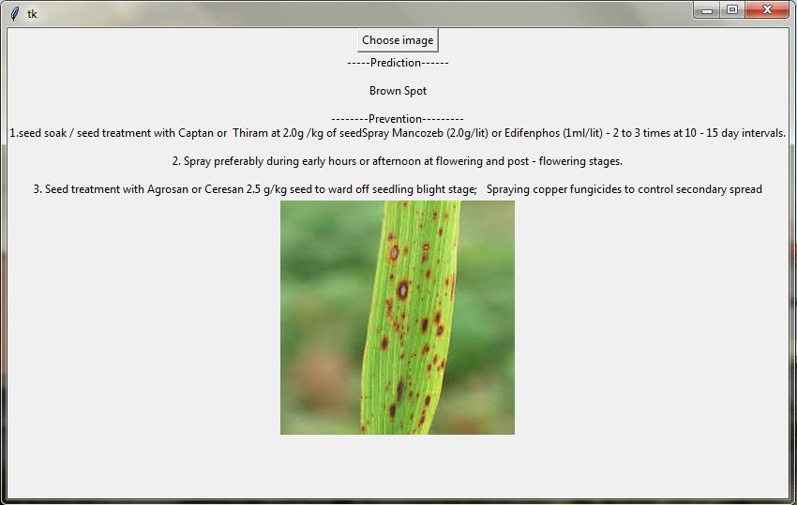

*Fig 4.1 ( prediction of brown spot)*

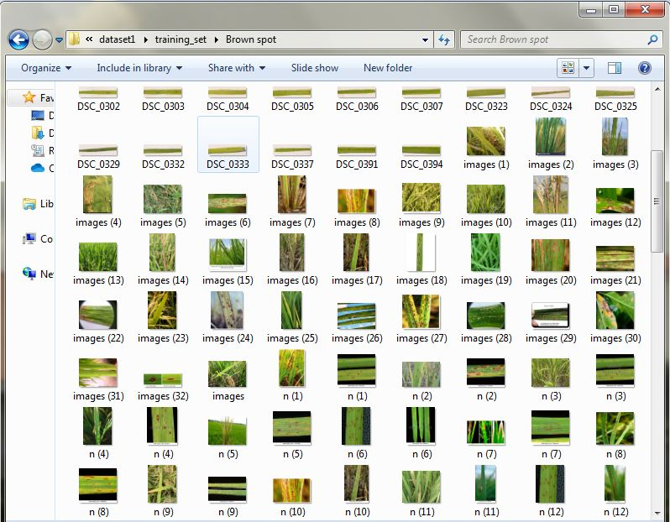

*Fig 4.2 (data set collection of brown spot)*

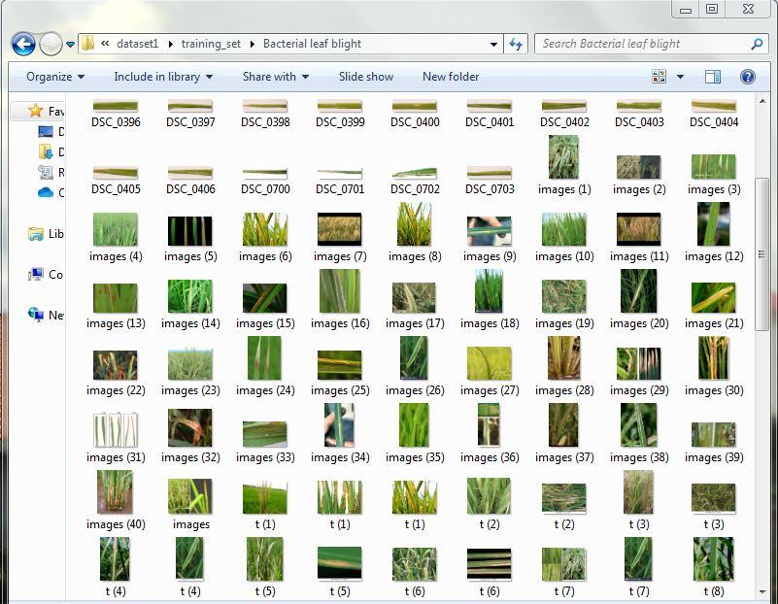

*Fig 4.3 ( dataset collection of Bacterial leaf blight disease)*

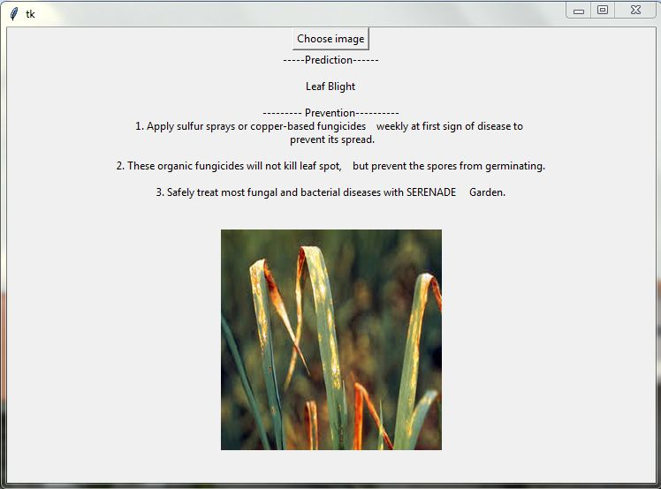

*Fig 4.4 ( Prediciton of Brown spot disease)*

**4.2 Data Modelling:**

Algorithm: Paddy crop disease classification using deep CNN.

***Input***: Paddy crop colored diseased images.

***Output***: Classified diseased images & Preventive Measures.

**Step 1**: Start.

**Step 2**: Train the 200 selected images with deep CNN and obtain the features for pattern matching.

**Step 3**: Select the colored image of a specific disease from testing database.

**Step 4**: Crop multiple diseased spot from the image and choose the ideal one.

**Step 5**: Apply deep CNN algorithm for images denoising

**Step 6**:Apply color and texture feature extraction

**Step 7**: Train the color and texture feature with classifier

**Step 8**: Determine and classify the images using deep CNN

**Step 9**: Highlight the disease affected and remedial measures

**Step 10**: Stop.

Among the 200 diseased images, number of truly detected disease images for Blast, Brown spot, Bacterial leaf blight (BLB), Sheath blight, false smut, Root knot nematode and White tip diseased identified were only 175 under various category. The detection success rate for considered paddy crop disease affected images is 87.50%. The proposed methodology ( Deep CNN ) is compared with the previous approach which was implemented by combining k-means & fuzzy logic classifier and CNN classifier.

**5. References**

[1] Savakar D G. and Anami B S, Improved Method for Identification and Classification of Foreign Bodies Mixed Food Grains Image Samples, International Journal of Artificial Intelligence and Machine Learning, Vol.9, Issue.1, 2009, pp.1-8.

[2] Vibhute A. and Bhode S K, Applications of Image Processing in Agriculture: A Survey, International Journal of Computer Applications, Vol. 52, Issue. 2, August 2012, pp.34-40.

[3] Landge P S., Patil S A., Khot D S., Otari O D. and Malavkar U G, Automatic Detection and Classification of Plant Disease through Image Processing, International Journal of Advanced Research in Computer Science and Software Engineering, Vol.3, Issue.7, July 2013, pp.798801.

1. **CONCLUSION**

The deep CNN is used for denoising images classification is used for disease classification. The work major concentrates on paddy crop disease such as Brown spot, Bacterial leaf blight (BLB). In the selected 500 images, denoised images are trained with the deep CNN a classifier and their features are taken for pattern matching; remaining 200 images are used for testing. The proposed methodology (Deep CNN classifier) is compared with the previous approaches which were implemented by combining k-means & fuzzy logic classifier and KNN. It is found that the proposed methodology has evidenced to achieve improved classification with an accuracy of 98.30 %. The research work can further extended to reduce the false classification by using other classifiers for feature extraction among the various paddy crop diseases.